Update kit for PT8603 SDI generator
with moving text in patterns

Supplement to: PT 5210 Reference: User’s Manual no. 9499 491 02211
This document describes how to update the PT8603 with moving text in signals and patterns.
The update of PT 8603’s can be divided in two classes:
- one needs an update of 5 programmable parts for adding moving text
- the second which need an extended update. This update also includes update of signal library bringing the PT8603 up to latest version

Specification for the moving text:
- 3 lines of text, each with a maximum of 32 characters
- Text may either be fixed or moving up and down.
- Text lines can be switch on/off as one group
- Position of text is user programmable
- All above parameters programmable from front plate or via RS232 remote control.

Parts to be exchanged:
The table below shows part numbers that has to be installed to have full functionality of the PT8603 and the moving text.
 |  | Position # | Description | Part number | Chksum
Full update: order no: 9449 900 22031 | Minimum update  Order no:  9449 900 22021 | V 53 | IC PROM SDI TEST Program  Sw version 3.9 | 4008 002 08041 | 5E9D
Full update: order no: 9449 900 22031 | Minimum update  Order no:  9449 900 22021 | V 54 | IC PROG PLD SDI TEST  ADDRESS DECODER | 4008 002 06552 | 9F4C
Full update: order no: 9449 900 22031 | Minimum update  Order no:  9449 900 22021 | V 63 | IC PROG PLD SDI TEST  H-COUNTER | 4008 002 06563 | B003
Full update: order no: 9449 900 22031 | Minimum update  Order no:  9449 900 22021 | V 75 | IC PROG PLD SDI DATA  MULTIPLEXER | 4008 002 06592 | 8980
Full update: order no: 9449 900 22031 | Minimum update  Order no:  9449 900 22021 | V 403 on PT5210 mainboard | IC PROM Master Program  Sw version 3.7 | 4008 002 08031 | A35F
Full update: order no: 9449 900 22031 | Addtional parts for the extended update | V 64 | IC PROG PROM TEXT PROM | 4008 002 05792 | AC27
Full update: order no: 9449 900 22031 | Addtional parts for the extended update | V 69 | IC PROG PROM SDI SEGMENT | 4008 002 05804 | 66F0
Full update: order no: 9449 900 22031 | Addtional parts for the extended update | V 79 | IC PROG PROM P1 SDI TEST | 4008 002 05824 | 4833
Full update: order no: 9449 900 22031 | Addtional parts for the extended update | V 80 | IC PROG PROM P3 SDI TEST | 4008 002 05834 | B331
Full update: order no: 9449 900 22031 | Addtional parts for the extended update | V 81 | IC PROG PROM P2 SDI TEST | 4008 002 05844 | 09FA

Installation of firmware on PT5210 main board

V 403
002 08031

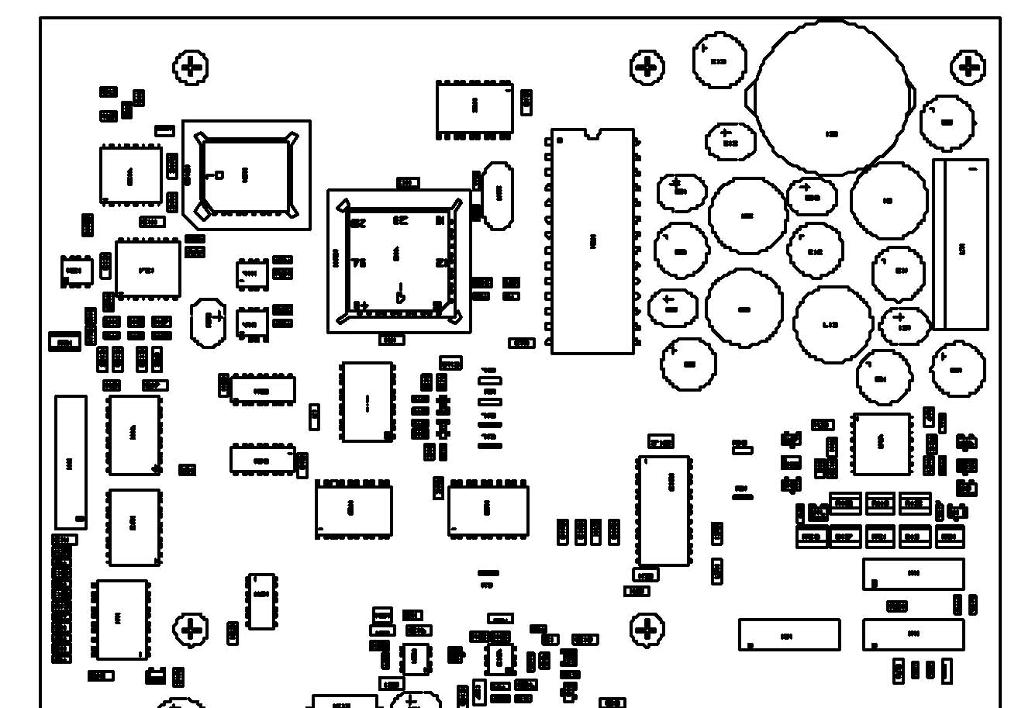

Picture 1: The positioning of the master processor PROM. The lower right corner on the PROM is indicated by a cut in the chip.
Mount the PROM with the above number and identification.

Installation of firmware on PT 8603 generator board
V 63
002 06563
V 75
002 06592
V 54
002 06552
V 53
002 08041
V 80
002 05834
V 81
002 05844
V 79
002 05824
V 64
002 05792
V 69
002 05804

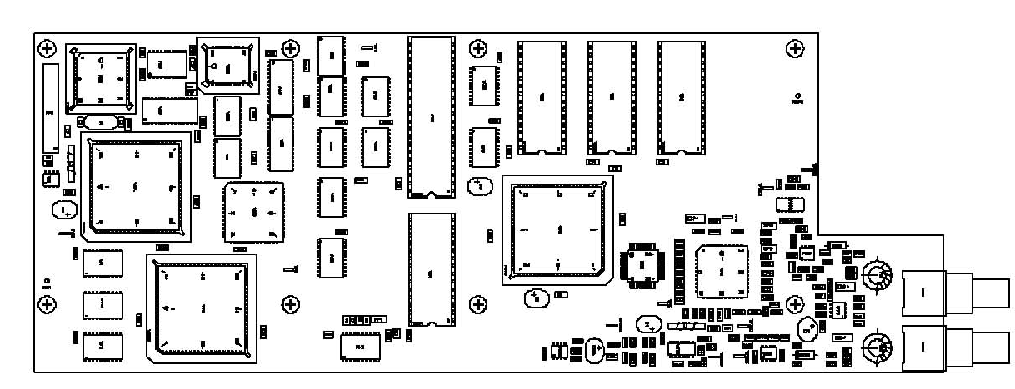

Picture 2 The positioning of the PROMs and PLDs on the PT8603.
Mount the parts according to the list above. Take care to polarize the parts correctly
For newer versions of the PT8603 only the 4 first parts in the list above have to be exchanged.
After the installation has been made, make a “Master Reset” of the instrument:
Keep left and right key buttons pressed while switching power on.

Menu description
After the PROMs and PLDs have been installed an extended menu structure is available for the PT8603
Please refer to the User’s manual for the preceding menus.

Text insertion options:
- 3 text lines can be added, user programmable. Text lines can be switched ON/OFF collectively
- Maximum 32 UPPER-case characters can be inserted per line
- Characters available: A-Z, 0-9, -, _ and space
- Text can be positioned across the screen in one text line height and in one characters width
- Text lines can be set into a scroll mode, scrolling up and down.

To change the functions of text in the patterns, select TEXT.
SUBMNU:SDI-SIGNAL/TEXT, edit text 
2NDMNU:<EDIT> On/Off MOVEMENT POS ESC

To change the text, select EDIT

Operation:
SUBMNU:SDI-SIGNAL/TEXT/EDIT E
L1:<DIGITAL1> SAVE ESC
- Use  and  buttons to select the line to edit (line 1 to 3).
- To open for editing of text, place cursor on text field and press EXECUTE
- Use the button to delete characters while backspacing.
- Scroll through the characters with the  and  buttons. The character being edited will flash during the editing process
- When the desired character appears, press  button to move to the next character to be inserted. Continue until the full string has be input.
- To exit the editor, press EXECUTE
- Finally move cursor to SAVE and press EXECUTE
- If no change is desired, move the cursor to ESC and press 
Leaving the function takes you back to the SDI-SIGNAL/TEXT menu.

To set the text On/ or Off, select EDIT
SUBMNU:SDI-SIGNAL/TEXT/On/Off 
TEXT:<ON> SAVE ESC

Operation:
- Use  and  button to select between On and Off
- Next move cursor to SAVE and press EXECUTE
- If no change is desired, move the cursor to ESC and press 
Leaving the function takes you back to the SDI-SIGNAL/TEXT menu.

Note:
Selecting OFF does not clear the text string setting, but setting all text line off at the same time.

To set the text moving or stationary
SUBMNU:SDI-SIGNAL/TEXT/On/Off 
MOVE:<ON> SAVE ESC

Operation:
- Use  and  button to select between On and Off
- Next move cursor to SAVE and press EXECUTE
- If no change is desired, move the cursor to ESC and press 
Leaving the function takes you back to the SDI-SIGNAL/TEXT menu.

To change the position of text, select POS
SUBMNU:SDI-SIGNAL/TEXT/POS E
X:<+40> Y: +9 SAVE ESC

Operation:
- Use the the or button to select horizontal position (X), or vertical position (Y)
- Use  and  buttons to change the position
- When the wanted position has been reached, place cursor on SAVE and press EXECUTE
- If no change is desired, move the cursor to ESC and press 
Leaving the function takes you back to the SDI-SIGNAL/TEXT menu.

Remote commands.
The commands available via RS232C have been extended to include the extended functionality.

In the OUTPut Subsystem the following has been added:
(The full string to be sent is listed)
Commands can either be in truncated form as indicated in capital letters or in long form using all letters.

Input of text
:OUTPut:SDIS:TEXT:STRing1 'XYZ'; (for line 1) or
:OUTPut:SDIS:TEXT:STRing1?; for query

Activating text ON/OFF and setting MOVEMENT
:OUTPut:SDIS:TEXT:ONOFF ON; to set text on and
:OUTPut:SDIS:TEXT:ONOFF OFF; to set text off
:OUTPut:SDIS:TEXT:ONOFF?; to query text on/off

:OUTPut:SDIS:TEXT:MOTion ON; to set text motion on or
:OUTPut:SDIS:TEXT:MOTion OFF; to set text motion off
:OUTPut:SDIS:TEXT:MOTion?; to query text motion

Setting of text position
:OUTPut:SDIS:TEXT:POSition 3,3; to set text position or
:OUTPut:SDIS:TEXT:POS?; to query text position

NOTE:
Command for :OUTPut:SDIS?; (query) does not output any text parameters due to the extended length of returned data

END OF DOCUMENT

